

# BT Super ESG Comparison Tool User Manual

|  |  |
| --- | --- |
| Section | Page |
| 1. Users 2. Abbreviations 3. End User Requirements 4. Development Environment Requirements 5. Development Environment Setup 6. Setup 7. Project 8. Database Layout 9. Adding/Updating new content 10. Deleting content 11. Technical Support | 45  45  45  45  45  46  46  48  48  50  50 |

|  |  |  |
| --- | --- | --- |
| Revision | Revision | Date |
| Initial Revision | A | 20/10/22 |

**Users**

This User Manual is intended for the admin of this tool.

It is not intended for public use.

**Abbreviations**

|  |  |
| --- | --- |
| IDE | Integrated Development Environment |
| NPM | Node Package Manager |

**End User Requirements**

For end users the requirements are a device capable of an internet connection and using a modern web browser.

**Development Environment Requirements**

**Hardware**

A modern Desktop or laptop setup with computer peripherals (Keyboard, mouse etc.)

**Software**

|  |  |  |
| --- | --- | --- |
| **Software** | **Requirements** | **Development use** |
| IDE | Able to open and edit JavaScript files | Visual Studio Code |
| Strapi | V3 | V3 |
| Node | Between V10.16.0 to V14.20.1 | V14.20.0 |
| NPM | After V6.0.0 | V8.11.0 |
| MongoDB | V3.x.x | V3.6.2 |
| Git | - | 2.35.1 |

**Development Environment Setup**

**IDE**

Visual Studio Code was used during development it can be downloaded from

<https://code.visualstudio.com/download>

**NPM**

NPM V8.11.0 was used during development.

In the terminal run the following command: ‘npm install -g npm@8.11.0’

**Node**

Node V14.20.0 was used during development. The version requirement for Node is due to Strapi V3 only being available with the listed node versions.

In the terminal run the following command: ‘npm install -g node@14.20.0’

**Git**

Git V2.35.1 was used during development. The newest version of git can be downloaded from

<https://git-scm.com/downloads>

**Strapi/MongoDB**

These will be automatically downloaded as a result of the setup in the next step.

**Setup**

Clone from github by inputting the following command to your terminal

“git clone <https://github.com/BrandonWebb5213/COMP3850-Group5-BTProject.git>”

Using the terminal navigate to the “mongo-db” folder

Run the command ‘npm install’

**Project**

The project is separated into two folders: frontend and mongo-db.

Frontend contains all code related to the display and retrieval of data from the database.

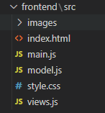

**Main**:

This file is responsible for handling actions completed by a user such as selecting a fund or concern or opening a menu.

**Model**:

This file is responsible for fetching and storing data from strapi API calls to the database.

**Views**:

This file is responsible for generating the HTML content that needs to be inserted into the webpage

**Index**:

This file contains the base skeleton of the webpage and provides sections where new HTML is added based on actions by the user.

**Style**:

This file controls the style and layout of the different components that make up the webpage

Backend contains the database and api setup via Strapi and the server to allow the app to run on the web.

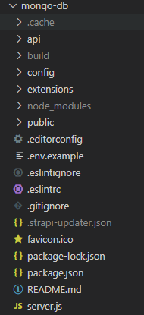

Server

Strapi

**Strapi**:

Strapi acts as an interface between the database and the webpage and also provides predefined API endpoints.

**Server**:

Server contains the code necessary to run the webpage on the internet.

**Database Layout**

|  |  |  |
| --- | --- | --- |
| Field (type) | Example | Description |
| Title (String) | AMP Super | The name of the fund |
| Concerns (JSON) | See templates after step 5 of Adding/Updating new content | An array containing all of the concerns and how a fund treats the concern |
| Description (String) | AMP believes that ESG factors play a huge role in the investment market in Australia and contributes to providing an ethical and sustainable return for their members. | A general paragraph about a fund based on information form their website |
| FundID (Integer) | 10 | A unique identifier for each fund |
| Assets (Float) | 64.90 (billion) | The amount of money invested by a fund reduced to 4 significant figures to improve readability |
| Members (Integer) | 854727 | The number of investors in a fund |
| URL (String) | https://www.amp.com.au/superannuation/responsible-investing | The URL leading to a funds ESG policy |
| Type (String) | Retail | The type of fund based on its responsibility to its shareholders |

**Adding/Updating new content**

1. To access the strapi admin panel navigate into the mongo-db folder and enter the command ‘npm run develop’
2. Log in with the details provided
3. Navigate to the Funds tab

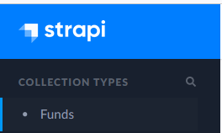

1. Click the Add new fund button or select an existing entry

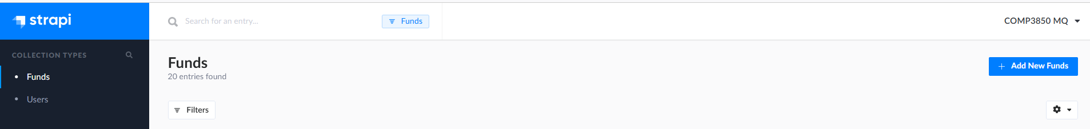

1. Fill out the details of the new fund. Title, Concerns, Description, FundID, Assets, Members, URL, Type

A template for the concerns field is provided below (**remove text between // and //**)

**Template for a new concern**.

Add id,desc,type then copy and paste into the array

{

"id": "last Concern ID + 1",

"desc": "...",

"type": "environmental/social/governance"

},

**Template for an array of concerns**

[

{

"id": "concern0",

"desc": "A summary on the fund's stance in this area...",

"type": "social"

},**//<=A comma if this is not the last concern//**

{

"id": "concern1",

"desc": "A summary on the fund's stance in this area...",

"type": "governance"

} **//<=No comma on the final concern//**

]

1. Click Save and Publish to update the database



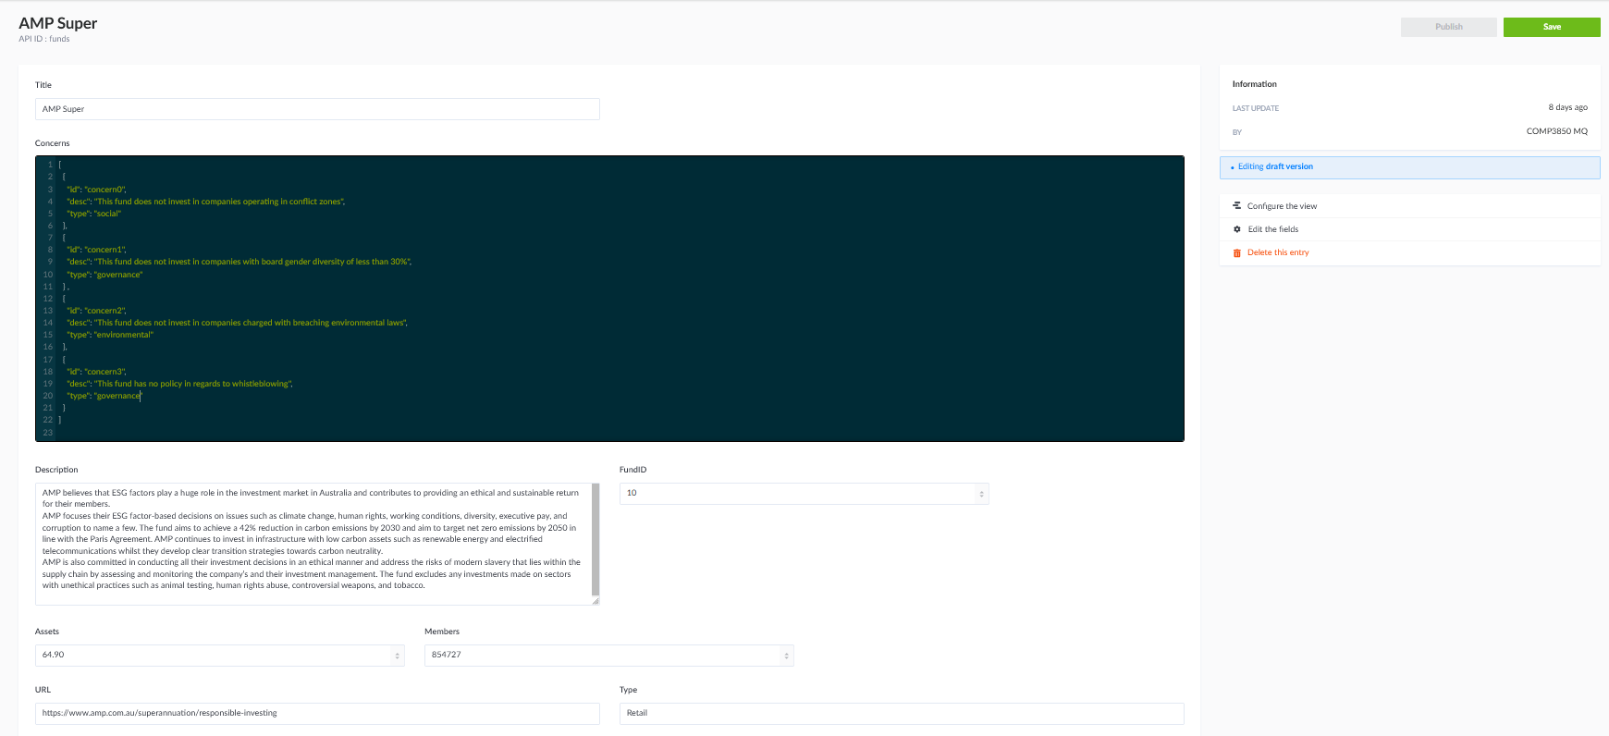

**Deleting content**

1. To access the strapi admin panel navigate into the mongo-db folder and enter the command ‘npm run develop’
2. Log in with the details provided
3. Navigate to the Funds tab



1. Click the bin button and confirm the deletion



**Technical Support**

For any unresolved issues or missing files contact joshua.aspinall@mq.students.mq.edu.au

# 